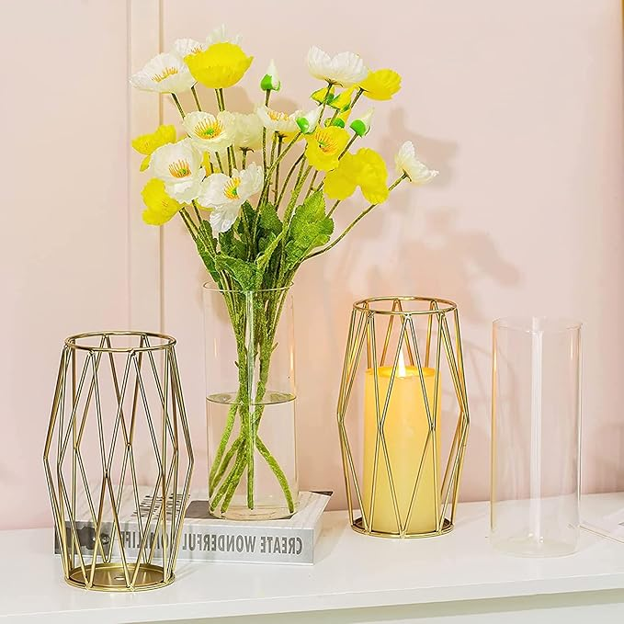

$19

Gold Modern Flower Vases for Centerpieces – Hewory 8.5inch Glass Vases with Metal Stand, Wide Big Tall Geometric Vase for Flowers, Flower Holders for Wedding Home Decor (Small,1pcs)